CAMPAIGN COMMUNICATIONS TOOLKIT

This toolkit provides all the information you need to help promote Do It London’s ‘Be Sure, Know the Four’ campaign.

This includes:
- Key messages
- Call to Action
- Social media posts
- Creative Assets (zip folder)
- Editorial copy

Please help us evaluate the campaign by recording and letting us know of any engagement your activities may have generated (e.g., likes, shares, link clicks).

For any queries, or to email your analytics, contact: Joss Dempster, LHPP Communications Lead - JDempster@lambeth.gov.uk

KEY MESSAGES

Use any of the following messages in your social media posts with the relevant images. Choose the ones that you think will resonate with your residents.

You are encouraged to tailor or combine these with local messages relevant to the campaign (e.g. where to get HIV test, local HIV awareness events, etc.)

- Four methods
  - Be sure, know the four proven ways to prevent HIV: regular HIV testing, condom use, PrEP, and UequalsU.
  - There are four scientifically proven, free, accessible ways to prevent HIV: regular testing, condoms, PrEP, and effective treatment as prevention (becoming ‘undetectable’).
  - Combination prevention is still the most effective strategy to prevent HIV.
- Testing
  - Testing for HIV is the only way to know your HIV status
  - Finding out you have HIV means you can start treatment, stay healthy & avoid passing the virus on to anyone else.
  - Get tested and use condoms to protect yourself from HIV & STIs if you are sexually active with new or casual partners.
- PrEP
  - It’s never too late to PrEP and get protected against HIV infection.
  - Frequent HIV testing and the offer of PrEP among those most at risk of HIV remains key to ending HIV transmission.
  - If taken correctly, PrEP can reduce your risk of HIV infection by up to 99%.
- Undetectable
  - It's been proven: a person on effective treatment with an undetectable viral load can NOT pass on HIV.
  - Most people living in the UK with HIV are on effective treatment and virally supressed, which means they can’t pass it on. This is known as U=U – undetectable = untransmissible.

LINK

All links are directed to the Do It London website home page. Please use the specific link below in all posts.

https://bit.ly/3SrgfrA

CALL TO ACTION

All posts should link to the Do It London website (unless another specific link is required)
- Visit Do It London website for more information
- Learn more about [Testing/Condoms/PrEP/Undetectable] and the other sure ways to prevent HIV

HASHTAGS

Use each one where relevant and space permitting
- #besureknowthefour
- #HIVTest
- #PrEP
- #UequalsU
- #GettingToZero
- #ZeroHIV

TAGS

Always tag DIL (and tag other organisations if necessary)
- Do It London @doitldn
- London Councils @londoncouncils
- Fast Track Cities London @londonftci

Sample posts

Testing for HIV regularly is the only way to know your HIV status.
Learn more about testing and the other sure ways to prevent HIV @doitldn
#besureknowthefour #HIVTest

It's been proven: a person on effective treatment with an undetectable viral load can NOT pass on HIV. #besureknowthefour proven ways to prevent HIV: regular #HIVTest, condom use, PrEP, and #UequalsU @doitldn

CREATIVE ASSETS

In the zipped creative assets folder, you will find

- x5 Graphics for social media – these are in one size for use on all social media channels
- x2 Artwork files – these are in one size to print as posters, flyers, etc.

Social media graphics

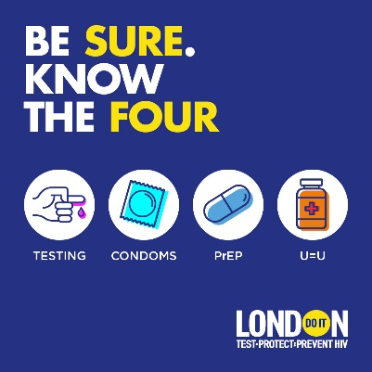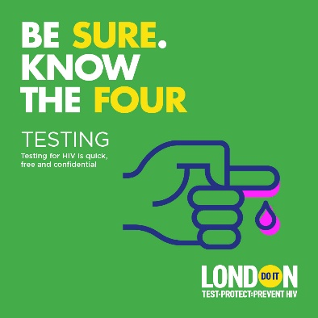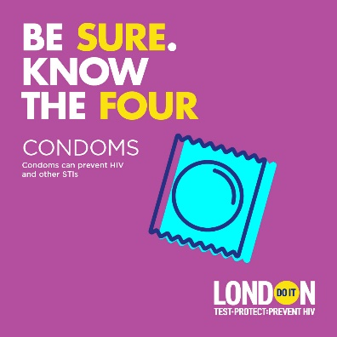

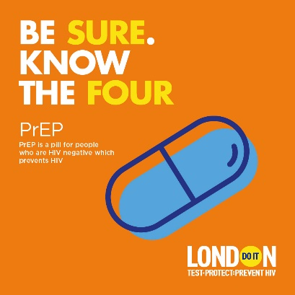
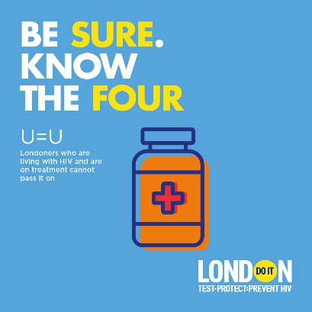

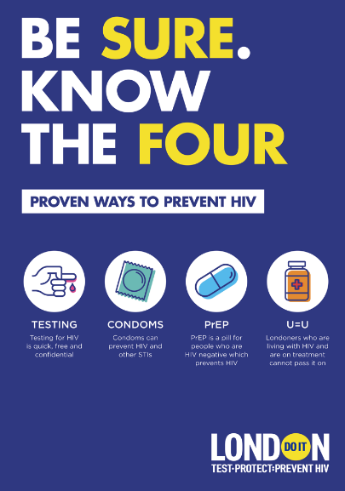
Artwork
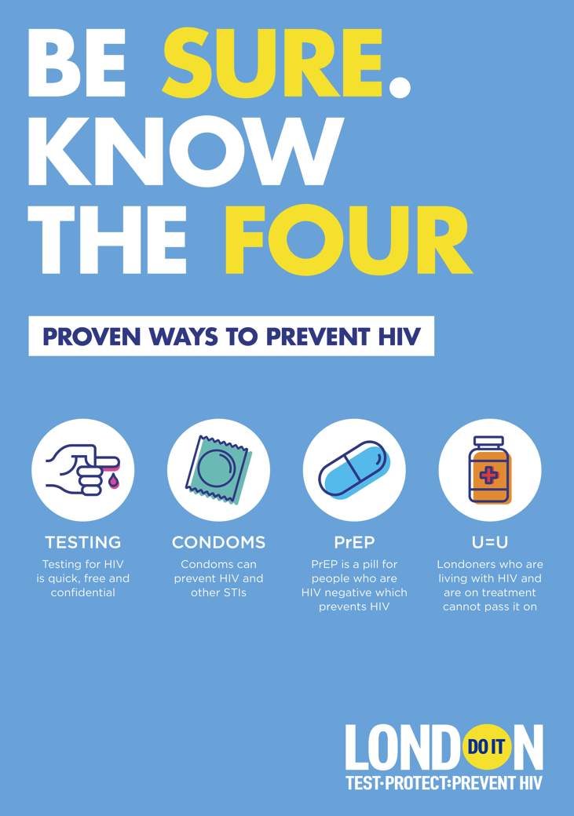

SCHEDULED POSTS

For the first two weeks after the campaign launch, please support the campaign with the specific posts below.

For the remainder of the campaign period, please check Do It London’s social media channels for messages to share.

w/c 14 November | We’re proud to support Do It London’s campaign which helps Londoners to protect themselves against HIV. Thanks to four sure ways, we can reach #ZeroHIV infections by 2030.  AND/OR:  Great to see #besureknowthefour campaign back again to remind Londoners about the four sure ways to prevent HIV.
w/c 21 November | [Insert Borough name here] – be sure, know the four proven ways to prevent #HIV: regular testing, condom use, PrEP, and #UequalsU.
w/c 27 November | [Please look out for DIL’s post regarding Nathaniel’s content for PrEP Awareness Week and like/share]
1 December | [Please look out for DIL’s post regarding World Aids Day and like/share]
w/c 20 December | [Please look out for DIL’s post regarding the festive season and like/share]
w/c 1 January | [Please look out for DIL’s post during this month and like/share]
w/c 1 February | [Please look out for DIL’s post during this month and like/share]

EDITORIAL COPY

Use this copy for newsletters, web pages, etc.

Do you know the four sure ways to prevent HIV?

London’s ‘Be Sure, Know the Four’ HIV prevention campaign is back to remind Londoners of the four sure ways to prevent HIV – testing, condoms, PrEP, and being Undetectable (also known as U=U).

The campaign by Do It London raises awareness of combination prevention to promote that HIV is preventable, that an HIV diagnosis is treatable, and that treatment acts as prevention.

In 2021, 33% of all new HIV diagnoses were London residents and 47% of all new diagnoses in London were in gay, bisexual and other men who have sex with men (GBMSM). The good news is that we are seeing the number of new diagnoses of HIV declining year on year. However, the high rates of HIV seen in London compared to other areas of England is a reminder of the importance of combination prevention.

Find out more about the campaign here: https://bit.ly/3SrgfrA

ENDS

